**Project Title**

**Project Documentation**

**1.Introduction**

**• Project title:SmartSDLC-AI-Enhanced Soft Development Lifestyle**

**• Team leader :JABRIN BANU A**

**• Team member :MAHESHWARI M**

**• Team member :MATHUMITHA T**

**• Team member:NALINI B**

**• Team member:PARAIMALESWARI G**

**2.project overview**

***• Purpose :***

**The purpose of a AI-Enhanced Software Development Lifecycle is to**

The **purpose of a Smart SDLC (AI-enhanced Software Development Lifecycle)** is to make the traditional software development process **faster, more efficient, and less error-prone** by integrating artificial intelligence at every stage.

Here’s a breakdown of its purpose:

1. **Automation of Repetitive Tasks**
   * AI tools can handle code generation, testing, bug detection, documentation, and deployment, reducing manual effort.
2. **Improved Decision-Making**
   * AI analyzes project data (requirements, risks, historical failures) to suggest better designs, architectures, and resource planning.
3. **Early Error & Risk Detection**
   * Smart SDLC uses AI-powered testing, static code analysis, and predictive models to catch defects and risks much earlier.
4. **Faster Development & Delivery**
   * AI accelerates coding, testing, and release cycles through automation, enabling faster time-to-market.
5. **Continuous Learning & Adaptation**
   * AI learns from past projects, user feedback, and production performance to continuously optimize the development lifecycle.
6. **Enhanced Collaboration**
   * AI-driven tools (like smart assistants and chatbots) help developers, testers, and project managers communicate more effectively.
7. **Quality & Security Assurance**
   * AI helps enforce coding standards, detect vulnerabilities, and ensure compliance with regulations.

***Features of Smart SDLC (AI-Enhanced):***

1. **AI-Powered Requirement Analysis**
   * Natural Language Processing (NLP) converts business/user requirements into structured specifications.
   * Identifies missing, conflicting, or unclear requirements early.
2. **Intelligent Project Planning**
   * Predicts project timelines and resource needs using historical data.
   * Automatically adjusts schedules based on risks or delays.
3. **Smart Code Generation & Review**
   * AI-assisted coding (e.g., GitHub Copilot, ChatGPT-based tools).
   * Automated code review for best practices, standards, and optimization.
4. **Automated Testing & QA**
   * AI generates test cases automatically.
   * Self-healing test scripts that adapt to changes in code/UI.
   * Predictive analytics to identify high-risk areas for testing.
5. **Predictive Risk Management**
   * Machine learning detects potential project failures, delays, or cost overruns.
   * Early alerts about performance bottlenecks or security vulnerabilities.
6. **Continuous Monitoring & Feedback Loops**
   * AI monitors application performance in real time.
   * Suggests optimizations and automatically triggers fixes or scaling.
7. **Adaptive Maintenance & Support**
   * Predictive maintenance based on error logs and usage patterns.
   * AI-driven chatbots for end-user support and ticket resolution.
8. **Enhanced Security Integration**
   * AI scans for vulnerabilities continuously (DevSecOps).
   * Detects anomalies in behavior for threat prevention.
9. **Collaboration & Knowledge Management** 
   * Smart assistants suggest solutions from past projects.
   * AI-driven documentation that updates automatically with code changes.
10. **Self-Learning Lifecycle**

* The system improves over time by learning from previous successes and failures.
* Each new project benefits from insights gained in earlier ones.

***Architecture:***

Below is a practical, technology-agnostic architecture for a **Smart SDLC** that embeds AI across the lifecycle (requirements → design → build → test → release → monitor → learn). I’ll give: (A) a layered architecture diagram (text/ASCII), (B) component descriptions and responsibilities, (C) typical data & control flows (sequence), (D) example technologies, (E) non-functional & security considerations, and (F) key metrics / KPIs.

# 1. High-level layered architecture (ASCII diagram)

+------------------------------------------------+

| Developer / Stakeholder UIs |

| (IDE plugins, ReqMgmt portal, Chatbots, UI) |

+------------------------------------------------+

▲ ▲

| |

+-----------------------+-----------+-----------------------+

| Smart SDLC Orchestrator (Brain) |

| (Workflow engine, policy engine, audit, RBAC, UI API) |

+-----------------------+-----------+-----------------------+

▲ ▲ ▲ ▲

| | | |

+-----------+---+ +-------+------+ +---+---------+ +--+------------+

| Requirements | | Dev & Build | | Test & QA | | Release & |

| Intelligence | | Automation | | Automation | | Deployment |

| (NLP, trace) | | (CI/CD, IaC) | | (Auto tests, | | (Canary, CD) |

+-----------+---+ +-------+------+ | self-heal) | +--+------------+

▲ ▲ +---+---------+ ▲

| | | |

+------+----------------+--------------+---------------+------+

| AI Services & MLOps Platform |

| (Model store, training pipelines, model serving, MLOps) |

+------+----------------+----------------+-------------------+

▲ ▲ ▲

| | |

+------+----+ +------+-----+ +------+-----+

| Observability| | Security AI | | Knowledge |

| & Monitoring | | (SAST/DAST) | | Graph/Repo |

+-------------+ +------------+ +------------+

▲ ▲

| |

+------+----------------+------+

| Data Lake / Repo |

| (code, artifacts, telemetry, logs, |

| test results, requirements) |

+-------------------------------------+

# 2. Component descriptions & responsibilities

**Developer / Stakeholder UIs**

* IDE plugins (AI autocompletion, vulnerability hints), chatbots for requirement clarification, dashboards for releases and risk.

**Smart SDLC Orchestrator (Core)**

* Orchestrates pipelines, enforces policies (compliance, security), stores audit logs, exposes APIs for teams and tools. Acts as the "control plane".

**Requirements Intelligence**

* NLP parsers converting PRDs/user stories to structured requirements.
* Requirements quality scoring; traceability matrix auto-generation.

**Dev & Build Automation**

* AI-assisted code generation, automated code style enforcement.
* CI pipelines augmented with predictive build prioritization.
* Infrastructure as Code templates suggested/validated by AI.

**Test & QA Automation**

* Auto-generated test cases (unit, integration, UI).
* Self-healing test scripts and prioritized test suites using risk models.
* Synthetic data generation for privacy-safe testing.

**Release & Deployment**

* Smart canary rollout decisions using performance anomaly predictors.
* Automated rollback triggers using learned thresholds.

**AI Services & MLOps Platform**

* Model training pipelines, model registry, model validation, explainability tools, feature store.
* Hosts models for code suggestion, defect prediction, requirement NLP, security scanning.

**Observability & Monitoring**

* Real-time telemetry, anomaly detection, root-cause suggestions, AIOps for on-call automation.

**Security AI**

* Continuous SAST/DAST using ML to prioritize vulnerabilities, detect supply-chain risks, detect anomalies.

**Knowledge Graph / Repo**

* Aggregates artifacts (code, docs, tests, incidents) into a graph to power search, reuse suggestions, and impact analysis.

**Data Lake / Artifact Store**

* Central store for logs, telemetry, test results, training data, and artifacts (binaries, containers).

# 3. Typical data & control flow (sequence for a new feature)

1. **Capture**: Stakeholder writes a feature in ReqMgmt portal → NLP module extracts acceptance criteria, risks, and dependencies.
2. **Planning**: Orchestrator uses historical data + ML to estimate effort, suggest resources, and create sprint tasks.
3. **Development**: Developer in IDE receives AI code suggestions; pre-commit hooks run ML-powered linters and vulnerability checks.
4. **Build**: CI starts; ML predicts flaky tests and reorders/parallelizes them; artifact pushed to registry.
5. **Test**: Test generator produces test cases; self-healing test runner adapts selectors; risk model focuses QA on high-risk areas.
6. **Release**: Canary rollout with AI deciding traffic split; observability detects anomalies and feedbacks to orchestrator.
7. **Runtime & Learn**: Telemetry and incident data flow to data lake; retrain predictive models; update knowledge graph and reuse hints.

# 4. Example technology stack (replaceable)

* **Orchestrator / Workflow**: Argo Workflows, GitHub Actions, custom orchestration.
* **IDE integrations**: Language Server Protocol plugins, Copilot/GPT-based services.
* **MLOps**: MLflow, Kubeflow, Seldon, or managed services (Vertex, SageMaker).
* **Data store**: S3-like object store + data warehouse (Snowflake/BigQuery) or on-prem Hadoop.
* **Knowledge graph**: Neo4j or open-source alternatives; semantic search via Elasticsearch + embeddings.
* **Testing**: Playwright/Selenium + test generation frameworks, TestOps platforms.
* **Security**: Snyk, Semgrep, internal ML SAST models.
* **Monitoring**: Prometheus + Grafana, OpenTelemetry, AIOps add-on (Dynatrace, Datadog).
* **CI/CD/Release**: Jenkins/ArgoCD/Flux + Kubernetes for deployment.
* **Secret & Policy**: Vault, OPA (Open Policy Agent).

# 5. Non-functional requirements & operational concerns

* **Scalability**: MLOps infra must scale for training and inference; model serving must be low latency for IDE/CI hooks.
* **Reliability**: Canaries & automated rollbacks; fallbacks when AI is unavailable (human-in-loop).
* **Explainability**: Provide human-readable rationale for AI decisions (why a test prioritized, why a vulnerability flagged).
* **Data Governance**: PII stripping, synthetic data usage, retention policies, and consent management.
* **Performance**: Cache model responses where safe; batch expensive scoring in CI.
* **Interoperability**: Well-defined APIs and webhooks so existing tools can integrate.

# 6. Security & privacy considerations

* **Least privilege & RBAC** in orchestrator and artifact store.
* **Model/data leakage** prevention (don’t send sensitive code to third-party models unless compliant).
* **Secure model training**: sanitize training data (remove secrets), track datasets used via lineage.
* **Audit & compliance**: immutable logs of AI suggestions, decisions, and approvals for audits.
* **Supply-chain security**: verify dependencies and use SBOM (Software Bill of Materials).

# 7. KPIs & metrics to monitor success

* Lead time for changes (deploy frequency, time to deploy)
* Defect escape rate (bugs found in production)
* Mean time to detect / resolve (MTTD / MTTR)
* Test coverage vs. test effectiveness (fault detection rate)
* AI suggestion acceptance rate (how often devs accept code suggestions)
* Model drift & model performance metrics (precision/recall for defect prediction)
* Security findings trend and mean time to remediate

# 8. Implementation roadmap (practical phases)

1. **Phase 0 — Foundation**: Centralize logs, artifacts, and CI; basic observability and policy engine.
2. **Phase 1 — Augment**: Add AI-assisted code completion, basic NLP requirement parsing, SAST automation.
3. **Phase 2 — Automate**: Auto-test generation, risk-based test prioritization, canary automation.
4. **Phase 3 — Optimize**: MLOps pipelines, knowledge graph, predictive planning, AIOps.
5. **Phase 4 — Continuous learning**: Closed-loop retraining from production telemetry and incident data.

**dynamically**

**update the frontend.**

**Frontend (Stream lit):**

**The frontend is built with Stream lit, offering an interactive web UI with**

**multiple pages including dashboards, file uploads, chat interface, feedback**

**forms, and report viewers. Navigation is handled through a sidebar using the**

**stream lit-option-menu library. Each page is modularized for scalability.**

**Backend (Fast API):**

**Fast API serves as the backend REST framework that powers API endpoints for**

**document processing, chat interactions, eco tip generation, report creation,**

**and vector embedding. It is optimized for asynchronous performance and easy**

**Swagger integration.**

**7. API Documentation**

**Backend APIs available include:**

**POST /chat/ask – Accepts a user query and responds with an AI-generated**

**message**

**POST /upload-doc – Uploads and embeds documents in Pinecone**

**GET /search-docs – Returns semantically similar policies to the input query**

**GET /get-eco-tips – Provides sustainability tips for selected topics like energy,**

**water, or waste**

**POST /submit-feedback – Stores citizen feedback for later review or analytics**

**Each endpoint is tested and documented in Swagger UI for quick inspection**

**and trial during development.**

**8. Authentication**

**each endpoint is tested and documented in Swagger UI for quick inspection**

**and trial during development.**

**This version of the project runs in an open environment for demonstration.**

**However, secure deployments can integrate:**

**• Token-based authentication (JWT or API keys)**

**• OAuth2 with IBM Cloud credentials**

**• Role-based access (admin, citizen, researcher)**

**• Planned enhancements include user sessions and history tracking.8.**

**Authentication**

**9. User Interface**

**The interface is minimalist and functional, focusing on accessibility for non-**

**technical users. It includes:**

**Sidebar with navigation**

**KPI visualizations with summary cards**

**Tabbed layouts for chat, eco tips, and forecasting**

**Real-time form handling**

**PDF report download capability**

**The design prioritizes clarity, speed, and user guidance with help texts and**

**intuitive flows.**

**10. Testing**

**Testing was done in multiple phases:**

**Unit Testing: For prompt engineering functions and utility scripts**

**API Testing: Via Swagger UI, Postman, and test scripts**

**Manual Testing: For file uploads, chat responses, and output consistency**

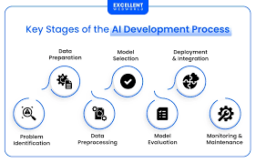 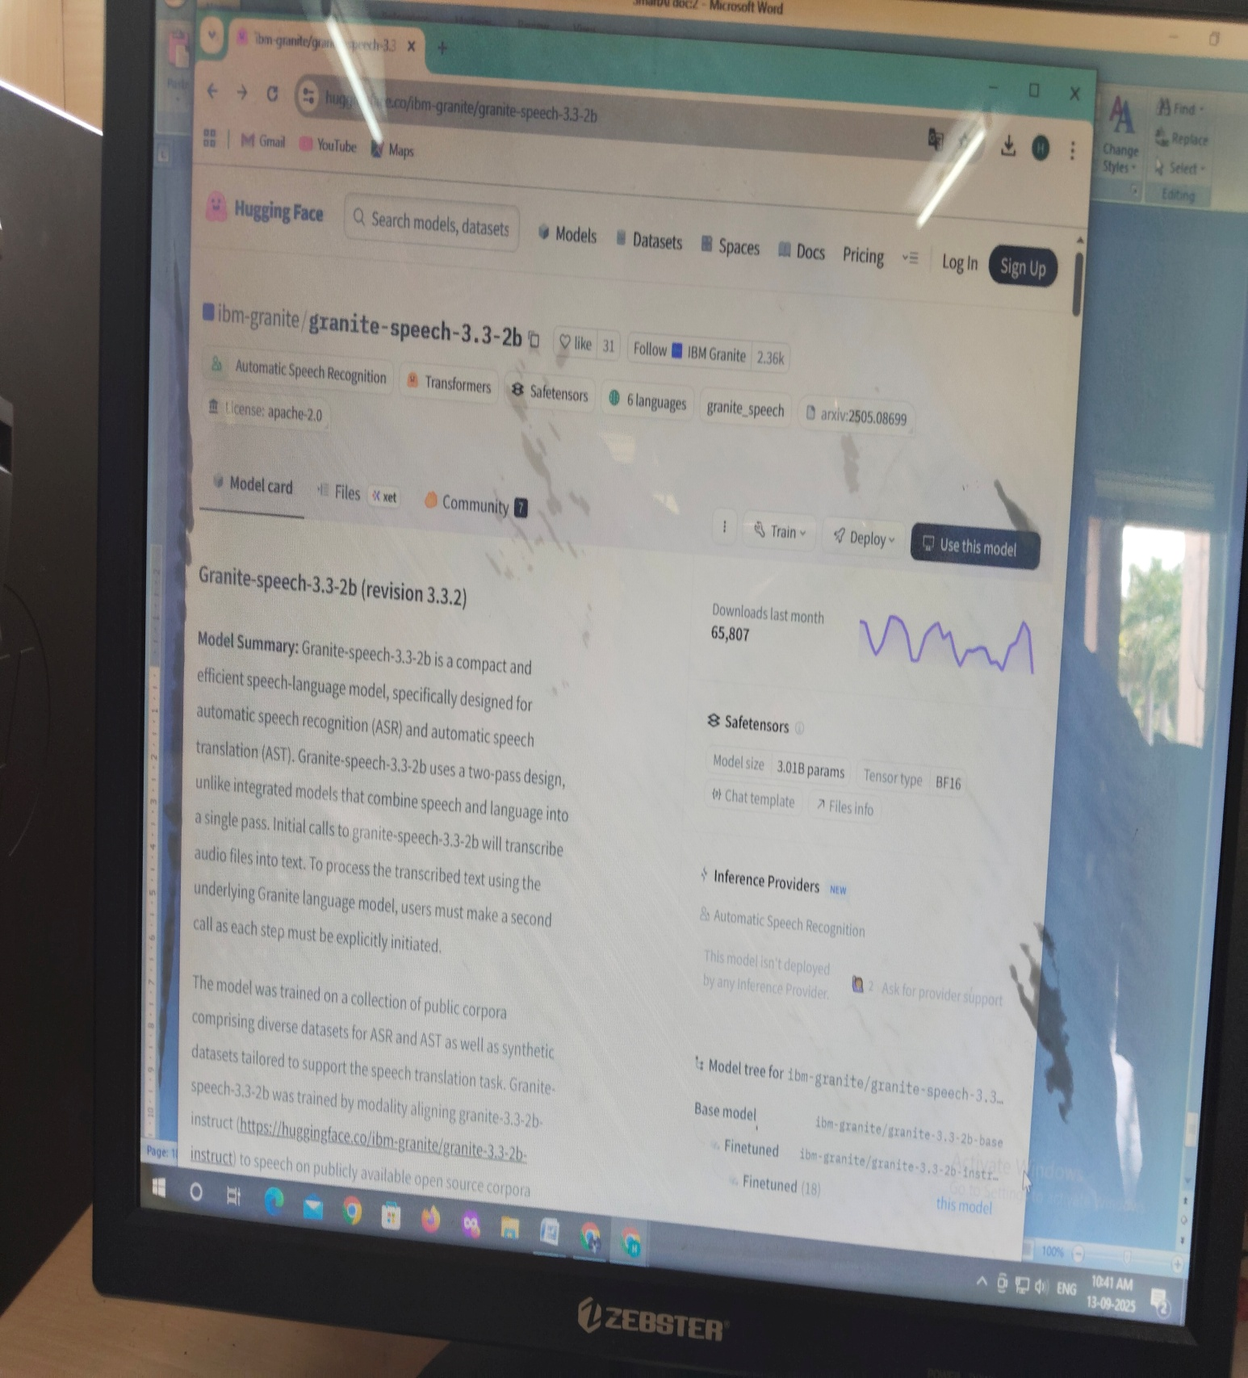

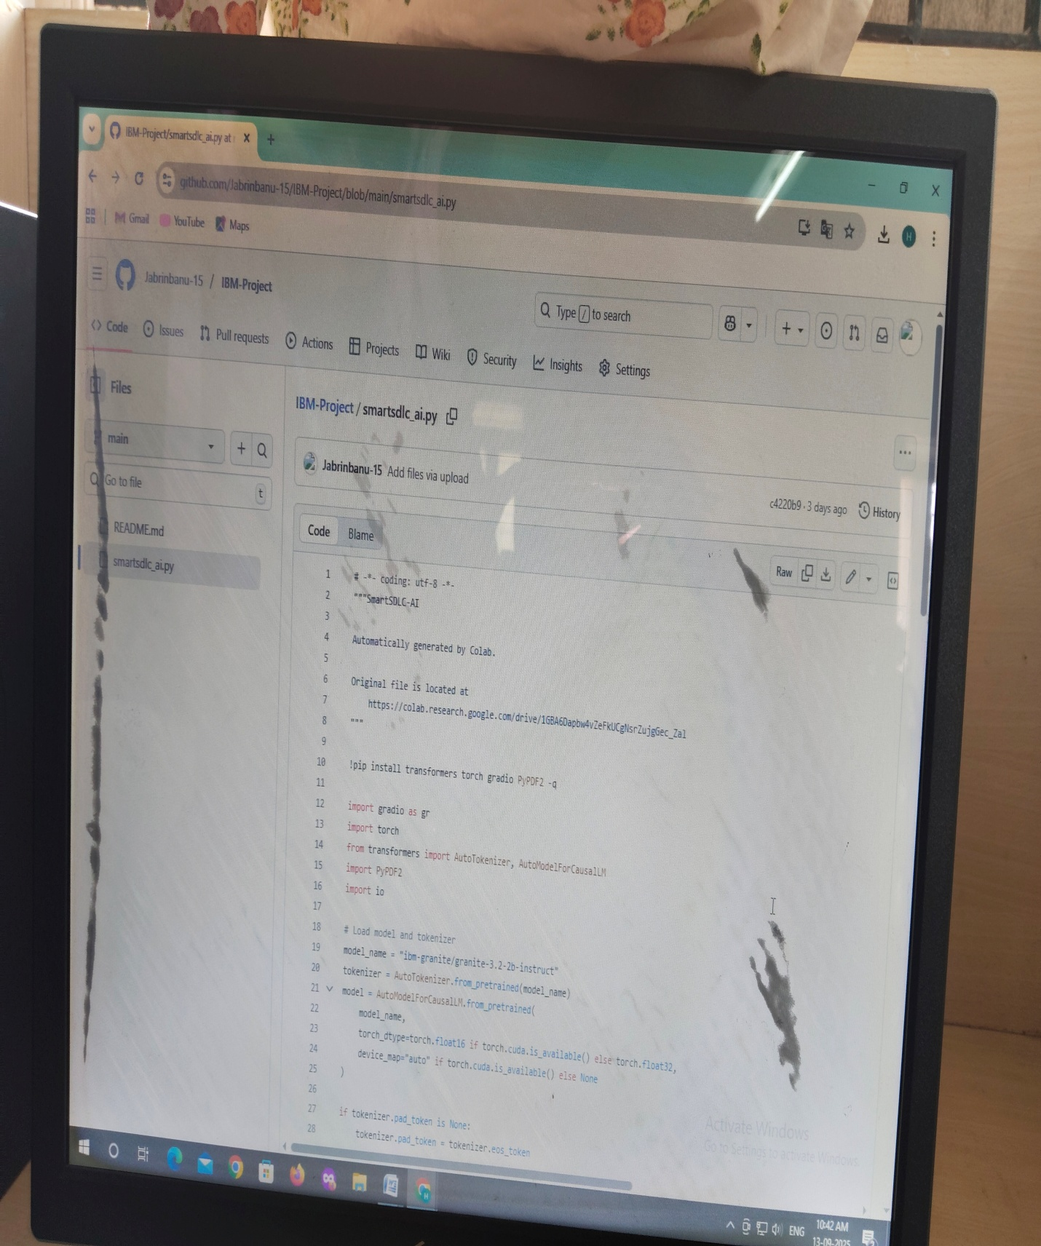

**Conclusion:**

The **Smart SDLC (AI-enhanced Software Development Lifecycle)** represents the next evolution of software engineering, where traditional processes are made **intelligent, adaptive, and predictive**. By embedding AI into every stage—from requirements gathering to development, testing, deployment, and maintenance—organizations can achieve **faster delivery, higher quality, reduced costs, and stronger security**.

Unlike the conventional SDLC, which often relies on manual effort and reactive fixes, the Smart SDLC leverages **automation, machine learning, natural language processing, and predictive analytics** to proactively identify risks, generate solutions, and continuously learn from past projects.

In essence, a Smart SDLC enables software teams to:

* **Accelerate innovation** with AI-assisted coding and testing.
* **Reduce errors and risks** through predictive insights and automated quality checks.
* **Ensure security and compliance** with AI-driven monitoring.
* **Continuously improve** by learning from data, user feedback, and operational metrics.

👉 The ultimate purpose of Smart SDLC is to create a **self-improving, intelligent development ecosystem** that supports rapid digital transformation and keeps pace with the growing complexity of modern software systems.